# Task Submission: Python File Handling and Automation

## 1. Project Overview
This project demonstrates the use of Python for automating file system tasks. It includes reading and writing different file formats (TXT and CSV), performing automation operations (rename, move, delete), and implementing robust error handling using `try-except` blocks.

## 2. Source Code
# ===============================
# File Handling and Automation Script
# ===============================

import os
import csv
import shutil

# 1. Writing to a Text File
try:
with open("sample.txt", "w") as file:
file.write("Hello, this is a sample text file.\n")
file.write("This file is created using Python.\n")
print("Text file written successfully.")
except Exception as e:
print("Error while writing text file:", e)

# 2. Reading from Text File
try:
with open("sample.txt", "r") as file:
content = file.read()
print("\nReading Text File:")
print(content)
except FileNotFoundError:
print("Text file not found.")
except Exception as e:
print("Error while reading text file:", e)

# 3. Writing to a CSV File
try:
with open("students.csv", "w", newline="") as file:
writer = csv.writer(file)
writer.writerow(["Name", "Age", "Marks"])
writer.writerow(["John", 20, 85])
writer.writerow(["Emma", 21, 90])
print("CSV file written successfully.")
except Exception as e:
print("Error while writing CSV file:", e)

# 4. Reading from CSV File
try:
print("\nReading CSV File:")
with open("students.csv", "r") as file:
reader = csv.reader(file)
for row in reader:
print(row)
except FileNotFoundError:
print("CSV file not found.")
except Exception as e:
print("Error while reading CSV file:", e)

# 5. Rename a File
try:
os.rename("sample.txt", "renamed_sample.txt")
print("\nFile renamed successfully.")
except FileNotFoundError:
print("File to rename not found.")
except Exception as e:
print("Error while renaming file:", e)

# 6. Move File to New Folder
try:
if not os.path.exists("backup"):
os.mkdir("backup")
shutil.move("renamed_sample.txt", "backup/renamed_sample.txt")
print("File moved to backup folder.")
except FileNotFoundError:
print("File to move not found.")
except Exception as e:
print("Error while moving file:", e)

# 7. Delete CSV File
try:
os.remove("students.csv")
print("CSV file deleted successfully.")
except FileNotFoundError:
print("File to delete not found.")
except Exception as e:
print("Error while deleting file:", e)

print("\nAll operations completed.")
```

## 3. Implementation Logic (Explanation)
- **File Handling:** Uses `open()` with modes `w` (write) and `r` (read). The `with` statement ensures files are closed automatically.
- **CSV Operations:** Utilizes the `csv` module to handle structured data with headers and rows.
- **Automation:** Uses `os.rename()` to change filenames, `os.mkdir()` to create directories, and `shutil.move()` to transfer files between locations.
- **Error Handling:** Every operation is wrapped in a `try-except` block to catch `FileNotFoundError` or other system errors, preventing the script from crashing.

## 4. Screenshots
Output
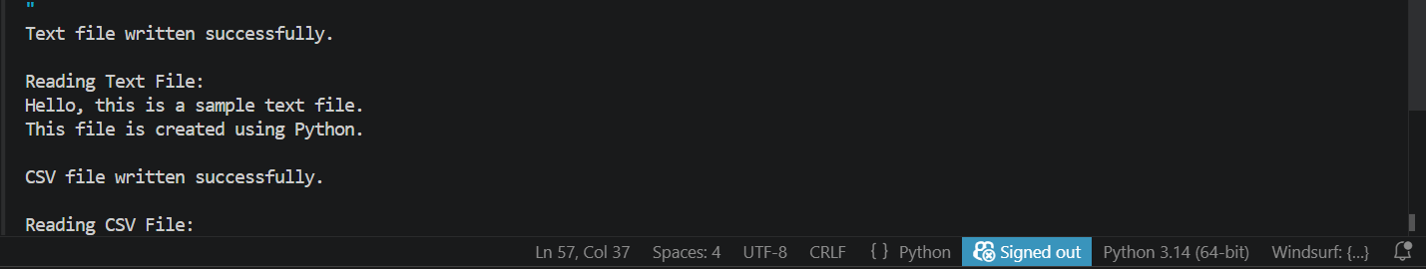
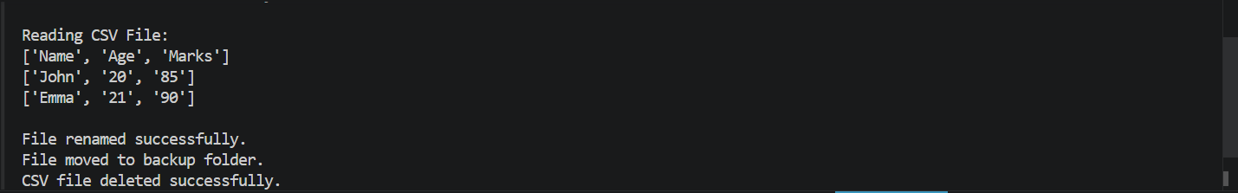
Before
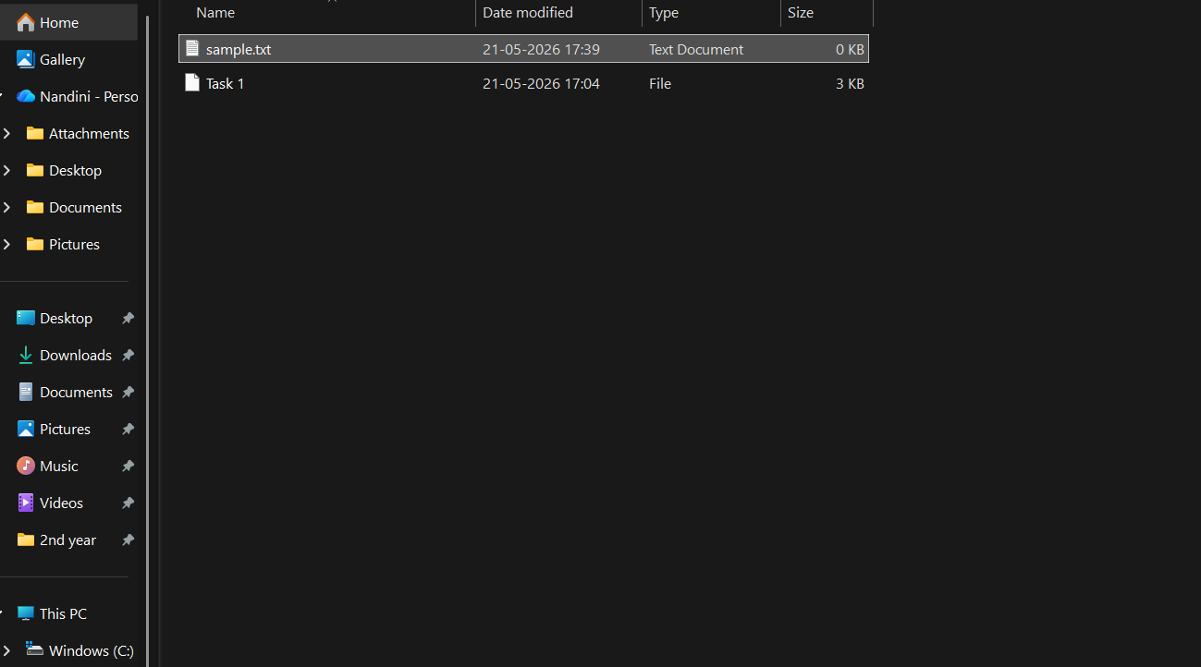
After
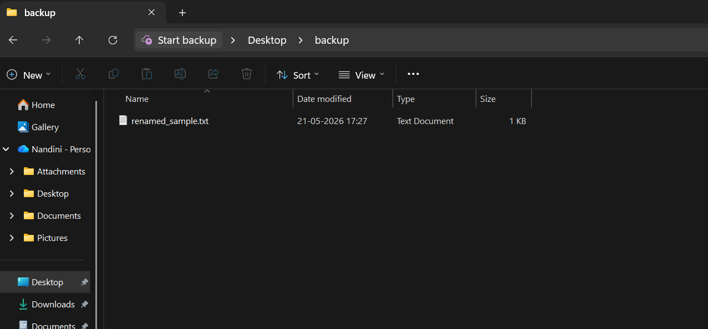
## 5. Project Links
-GitHub Repository: https://github.com/nandinivetcha-hub/python-file-handling-task1.git

